Othello: The Remix
https://www.unicorntheatre.com/othello-the-remix schools resource pack
Music, Lyrics & Direction by GQ and JQ
Starring Jackson Doran, GQ, JQ, Postell Pringle & Clayton Stamper

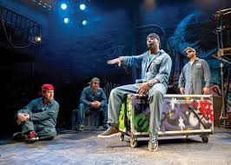
How do we get our next generations to appreciate the works of William Shakespeare? In fact, how do we get some of our fellow theater-goers to even go to a Shakespeare comedy, let alone a tragedy
“My first encounter with Shakespeare was pretty horrendous,” says GQ, one half of Chicago’s Q Brothers, recalling his teen years struggling with a reading disability that hindered his enjoyment of the Bard.
The adaptation casts Othello as a rap king in the vein of Jay-Z, with Cassio as a Vanilla Ice–like performer who signs a record deal before the far more talented underground sensation Iago. Desdemona is an aristocrat’s daughter who follows the trio on tour despite her father’s orders; a groupie, she’s loved Othello since his first mix-tape.
“It has a darker tone,” JQ says of Othello’s music. “There’s a lot more strings in the beats, a lot more minor keys. There was a lot of inspiration from horror movies.”
The brothers’ time on tour showed them a crowd-pleasing production doesn’t need fancy technical flourishes. “That’s one thing we realized: Keep the lights simple, keep the set bare and let the lyrics paint the picture,” JQ says.
“The Qs have an amazing sense of humor,” says Chicago Shakespeare creative producer Rick Boynton, who’s been a guiding presence for the Q Brothers. “And with Othello: The Remix, we’ve found a great balance between a lot of humor and the tragedy of Othello. What they’re doing is fresh. It embraces the art form of hip-hop beautifully, but it doesn’t throw Shakespeare out.”
You need not be a fan or expert in the world of hip hop music to appreciate the polish and stamina this cast of four, plus crow's nest DJ Clayton Stamper, bring to audiences of all ages and experiences.
In this delirious delight, developed with Chicago Shakespeare Theater’s creative producer Rick Boynton, five players take only 90 minutes to deliver a freely funky, hip-hopped remake, complete with boom-box beat and breakout poetry, of how the Moor’s “green-eyed monster” of jealousy, inspired by his malevolent aide Iago, makes him kill Desdemona, the love of his life and, now, the excuse for his death. -

If iambic pentameter seemed the natural cadence for Shakespeare’s blank verse, rap rhythms take the pulse of our times. Marvels of supple, split-second timing and gangbanging hubris, the bouncing, bubbly dialogue is as infectious as repetitious. The result is an intricately coordinated collaboration of music-video choreography, pulsating beat backdrop by disk-jockey Clayton Stamper, Jesse Klug’s wizard lighting design, James Savage’s inexhaustible sound design, and Scott Davis’ ingenious props and costumes.

“Othello: The Remix” can be congratulated on capturing the essence of the Elizabethan classic without utilizing a sentence of the Bard’s script, substituting streetwise dialogue salted with contemporary references to Eddie Murphy, Dumbledore, and the like. The bottom line is that the show is superior rap and very good Shakespeare, not a playgoing package on offer every day.
They are all spectacular in dominating the dense rap language, their motors running from first moment to final blackout. The interaction within the ensemble, the sheer memory skills required to master the rap lines, and the quick changes in character are stunning.
The adaptation retains the high drama of the original but the unique Q Brothers rap-driven wit is continually in evidence. “The Remix” remains a tragedy but there are lots of laughs along the way, all legitimately within the frame of Shakespeare’s story. They are in constant physical animation, firing off their rhyming lines at the speed of sound. The language comes out so fast and furious that it’s almost impossible for the spectator’s ear and mind to process every word. But what does get absorbed is pretty wondrous.
This hip-opera adaptation of Shakespeare’s classic has a powerhouse score and impeccably sleek production value.
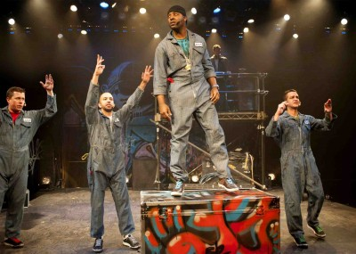
Othello: The Remix has proudly come home to roost. Following a world premiere at London’s 2012 Cultural Olympiad—with subsequent runs in both Germany and Scotland—CST’s commissioned hip-hopera is an unqualified success. Freely adapted from Shakespeare’s original tragedy, OTR is the brainchild of Chicago-natives GQ and JQ (collectively known as The Q Brothers), who along with CST’s Creative Producer Rick Boynton, have brought us this taut and engrossing re-think on an old classic.

Re-imagining the world of Shakespeare’s Venetian army as that of a vast hip-hop empire, the traditional Moorish general is here recast as MC Othello (Postell Pringle), who rises up from the ghetto to reach the heights of music stardom and the full extent of the “American dream.” His wife Desdemona—in OTR, represented as an ethereal songbird, trilling soulful R&B in some faraway Arcadia—sits devotedly at his right-hand side. True to custom, MC Othello has promoted Cassio (Jackson Doran) to the first-ranks of his crew. Cassio being a ham-boned pop rapper in his own right, MC Othello agrees to release his next album. This of course angers the “hip-hop purist” Iago (GQ), who solemnly vows revenge on the Moor. Soliciting the aid of the nerdy light techie, Roderigo (JQ), Iago thus sets in motion an otherwise all-too-familiar plan to poison MC Othello against his wife. With a DJ (Clayton Stamper) propped on top some tagged scaffolding, the whole play is set to a continuous hip-hop rhythm, with major production numbers as glitzy and well-polished as they are powerfully dramatic.
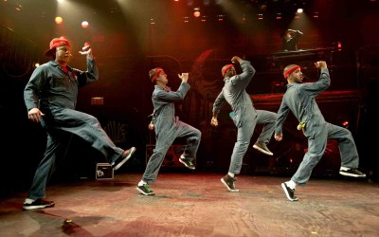
OTR’s production elements—including Jesse Klug’s high-octane concert lighting, James Savage’s boldly beat-heavy sound design, Scott Davis’s tagged and bare bones set—all conspire to create an event that artlessly combines the showy glitz of a rock concert and the narrative pull of an American musical. Without a doubt, The Q Brothers have written a score that manages to be both emotionally compelling yet also incredibly funny, subversively lambasting hip-hop’s purist sub-strains, subtly aligning them with Iago’s own reactionist intolerance for the commercial success of his peers. For ever since DJ Kool Herc started mixing samples out of his South Bronx apartment, claims to hip-hop’s “authenticity” have driven critical reactions. Still, it no minor point that a musical form once used to vent the frustrations of living in the projects or to voice the limitations of the civil rights movement is now being appropriated to the needs of a classical theatre repertoire. At the very least, such issues should be a crucial part of post-show discussions emerging around OTR. Although it would be equally unfair to let such issues define our reactions entirely.
For it is equally true that this collection of able performances looks and sounds just about “as real” as it gets. In the title role, Postell Pringle’s MC Othello builds intensely over the course of an hour and a half, forcefully self-destructing in a skillfully constructed murder scene. As the scheming Iago, GQ’s harrowing Slim Shady-esque comedic performance is only the veil for an otherwise fiercely angry young man. And Jackson Doran and JQ show themselves equally instinctual performers, able to throw down artfully nuanced comedic characters in-between the edges of two paper-thin beats.
For all its glitzy good looks and hip-hop humor, Othello: The Remix has lost nothing in translation.
The best hip-hop is pure poetry. It highlights human triumphs and flaws, finding lighthearted moments in the saddest tragedies. Hip-hop has its own language: words spilling over one another, multiple callbacks and cultural references and, always, an infectious hook. With these qualifications in mind, Shakespeare was a hip-hop virtuoso. Marrying hip-hop and Shakespeare is both a natural pursuit and a subtle, demanding art. The Q Brothers – born and bred in Chicago, now acclaimed worldwide – step up to the plate in their third work. Othello: The Remix is a masterful hip-hop homage to the classic tale and a fresh spin on an all-too-human story: a man who believes his own hype, but is just paranoid enough to let manipulation rear its ugly head.
In this story, Othello rises from prison to superstardom, rapping the stories of his rough ghetto roots. He elopes with beautiful and privileged Desdemona, whose angelic voice has its own inner pain. But during a tour that will make crossover stars of Othello and his pretty-boy friend Cassio third wheel Iago has his own agenda: destroy everything Othello holds dear, with a few dropped hints and a strategically placed bauble.
the Q Brothers bring their own brand of the Bard to . They don’t just shake up the genre, they blow it up with sick beats (thanks to onstage wise words and a language style that’s both wildly different and oddly similar to Shakespeare’s couplets. And it’s funny. In the play’s first lines, a character notes that this is a tragedy, but there’s comedy in it. Certain roles (GQ’s befuddled Brabantio, JQ’s sassy Bianca and the vain but goofy Cassio) provide excellent comic relief, but the Q Brothers also find subtle and broad opportunities to lighten the moment just when events turn nasty. Rather than detracting from the drama, the comedy augments it, highlighting the tragedy by providing a sharp but seamless contrast.
Yo Billy Shakes, turn your beatbox up to high
Cause “Othello’ (yeah, “The Remix”) is aimin’ for the sky.
It’s scratchin’ your iambic in a “pent”-up sort of way
Yeah, those Brothers known as Qs are givin’ rappers their best day.
Their Moor’s a big chart-topper with a tour headin’ out
Desdemona is the singer with some bling from “O” to tout
Five guys up there on stage are givin’ every single breath,
And a pillow’s all that’s needed when poor “D” is put to death.
To cut to the chase: “Othello: The Remix” — the 90-minute, lightning-fast, hip-hop version of Shakespeare’s tragic tale of jealousy and self-doubt, is absolutely brilliant and immense fun. The show, which wholly re-imagines the original, was devised for London’s 2012 “Globe to Globe” Cultural Olympiad, and subsequently toured to Edinburgh and Germany. And while it has been “transferred” from Renaissance Venice to 21st century America, it turns out to be every bit as faithful to the play’s core meaning and message as poor Desdemona was to Othello.
While there was certain fun to be had in Othello's modern setting and the quick character changes of the cast, the performance did not shirk the darker elements of the play. Desdemona's demise was shocking, her non-presence in the play (only her pre-recorded singing voice is heard) a clever way of highlighting that her transformation occurs only in Othello's head, rather than in reality.
The show fizzed along with so much verve that the story with its familiar themes of jealousy, friendship and betrayal was utterly engrossing - even for those members for the Globe audience that one suspects were not witnessing their first performance of Othello.
The actors make clear in a rap at the beginning of the play that they are part of a tradition of reworking familiar stories that Shakespeare himself borrowed from the Greeks. If the writers felt they needed to justify touching one of Shakespeare's finest plays, they needn't have bothered: the show is a triumph from beginning to end.
The Q Brothers
OTHELLO: THE REMIX
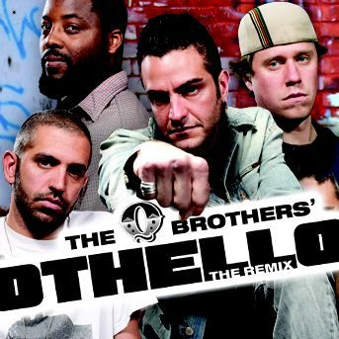

A fresh urban take on Shakespeare's tragedy spun out, smashed up and lyrically rewritten over original beats.
The Q Brothers are America's leading reinterpreters of Shakespeare through hiphop. They
return to London following their award winning production Funk It Up About Nothin
which received rave reviews from its world premiere at Chicago Shakespeare Theatre and subsequent international tour.
Recipient of the 2008 Regional Theatre Tony Award, Chicago Shakespeare Theater is
dedicated to producing extraordinary classic productions; unlocking Shakespeare's work for audiences from all walks of life.
"Absolutely brilliant... Just as Shakespeare helped shape English, rap has dramatically refashioned it" Chicago Sun-Times
Written, Directed and Music by GQ & JQ
Developed with Rick Boynton
Chicago hip-hop sensation Q Brothers take their inspiration from the original genius lyricist: Shakespeare. Together, the brothers create fiery, feisty musical ad-rap-tations of Shakespeare's plays.
MC Othello gets out of the ghetto and goes straight to the top. He wins the respect of the music industry, the adulation of fans and the heart of the beautiful singer Desdemona. But he's also attracted the spite of hip-hop purist Iago, who has something more sinister planned for Othello than a rap battle.
Innovative, intelligent and street smart, Othello: The Remix turns the volume up on Shakespeare's rhymes and rhythms for a new generation to tune into.

Suitable for ages 10+

