ESPECIALLY FOR LOWER PRIMARY STUDENTS – A MUSICAL EVENT
JAZZAMATAZZ  ALI MCGREGOR  AUSTRALIA  This show was filled with dancing children all having a great time and thoroughly enjoying themselves - Broadway Baby ★★★★★  Direct from a smash-hit season in Edinburgh, the award-winning Jazzamatazz is an hour-long afternoon of snappy groovin’ jazz crafted especially for lower primary students aged five to seven-years old.  Jazzamatazz is performed by the multi-talented opera singer, actress, jazz-singer and mother, Ali McGregor. Ali and her band give you some dancing tips for rock ‘n roll, swing and jive. There’s also sing-along and action songs, old favourites and some nice, new numbers. | 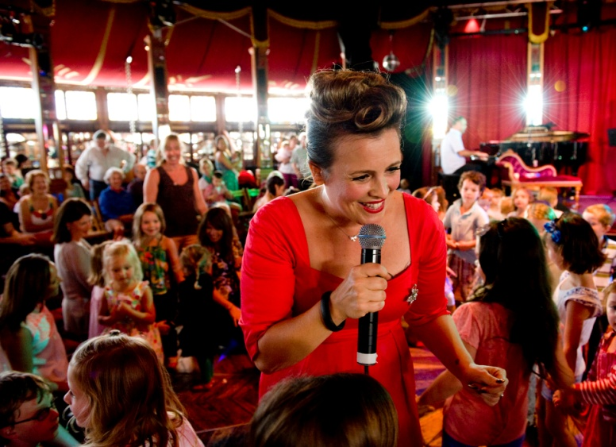  *Recommended for ages 5 – 7  50 mins duration

JAZZAMATAZZ SCHOOLS BOOKING FORM
Name: |  |  |  |  | Position:
Phone: |  |  |  | Ext. | Mobile:
School: |  |  |  |  | Email:
School address:
Please circle your preferred show and write the total number of tickets you wish to book.
PERFORMANCE | PREFERRED TIME (PLEASE CIRCLE) |  |  | PRICE | No. of STUDENTS | YEARS | No. of TEACHERS | TOTAL No. of TICKETS | AMOUNT
JAZZAMATAZZ |  | [ 4-5006)
Festival Tent | Friday 6th March |  |  | $10.00 |  |  |  |  | $
Aotea Square | 10.30 am |  | 12.30 pm |  |  |  |  | TOTAL
Teachers get 1 ticket for every 10 students – extra adults must purchase tickets.
Please scan or attach this form and send to mailto:schools@aaf.co.nz
or fax 09 309 0176 or post to Education Bookings PO Box 5419, Wellesley Street Auckland 1141

