Fela!
‘‘Delivering exuberant storytelling through song and dance…”
What Is Fela! About?
Upon entering the Eugene O’Neill Theatre, audiences of Fela! find themselves in the “Afrika Shrine,” a 1970s Lagos nightclub and political stage belonging to the show’s namesake central character, Fela Anikulapo Kuti. Through song, dance and onstage banter with the audience, Fela (a real-life historical figure from Nigeria) begins to share the extraordinary details of his life, from his travels across the globe to his development of the show’s signature fusion of jazz, funk and traditional African drum music known as Afrobeat. Fela, his band and his tribe of wives (the real man had, at one point, 27 spouses) also depict their politically oppressed Nigera, a country terrorized by its own government, and the crimes committed by their leaders against them. As stories from tragic to inspiring unfold, exhilarating song and dance drive one man’s legendary journey forward.
What Is Fela! Like?
Audiences, take note: Fela! is not your grandmother’s musical. With its live band playing throbbing Afrobeat onstage before the show officially begins, this piece is more than a musical; it’s a narrative concert. And the character of Fela assumes the roles of narrator, protagonist and, occasionally, villain. Fueled by its star’s swagger, music and choreography (you won’t see dance like this anywhere else on Broadway), the show moves at a rapid, rhythmic pace, at some points frothing to a frenzy so exuberant dancers spill off the stage and into the aisles. It’s not all fun and games, however. Moments of tragedy and reenactments of historical violence color Fela! with strokes of darkness, making its hip-swinging party vibe all the merrier when its happening.
Is Fela! Good for Kids?
While this is music almost everyone will find themselves moved by, Fela the man was hardly a role model. A brash, jaded rock star, Fela was a womanizer, rabble-rouser, law-breaker and unapologetic fan of marijuana. As such, the show features bad language, mild sexual content, drugs and violence which may be inappropriate for young viewers. It’s also true that there’s a fair amount of rump-shaking and bare skin in the production, but both are rooted in traditional African dance and tribal garb, and therefore should not be misconstrued as vulgar. Consider this one a solid sell for mature ‘tweens and teens, particularly those with an interest in music or dance.
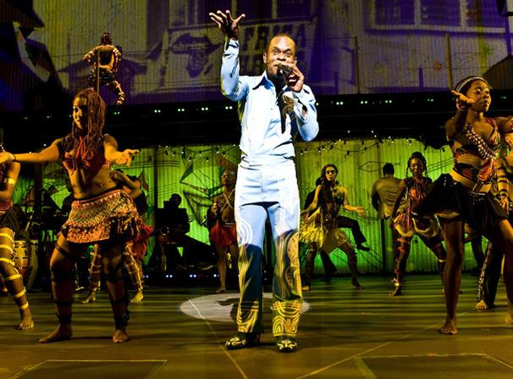
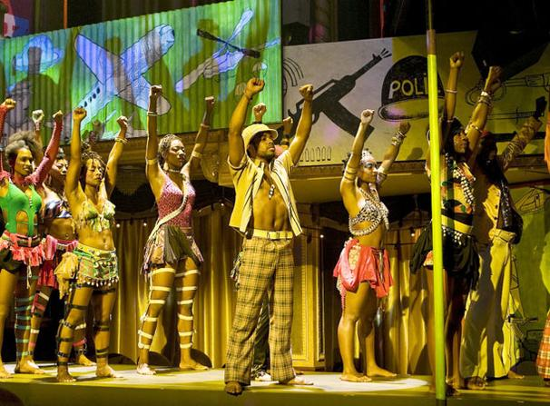
‘‘"The show's raison d'etre is the music, ferociously performed by Antibalas, a Brooklyn-based band. [The] choreography...is outstanding and beautifully performed by a hardworking, sexy ensemble."’’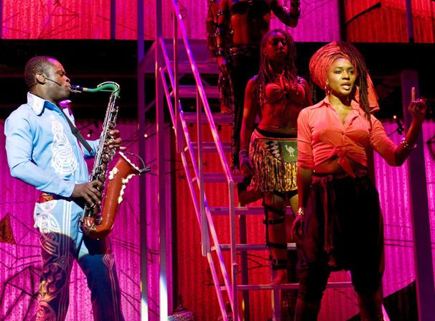
“…spectacular African-inspired dances that fill every centimeter of the two-tiered set…”

