Akram Khan Dance Company
- journeys across boundaries to create uncompromising artistic narratives.
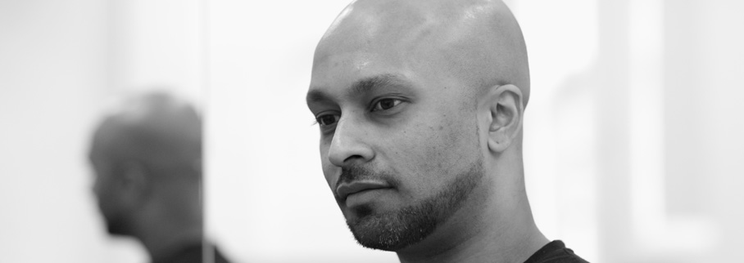
Akram Khan Company produces thoughtful, provocative and ambitious dance productions for the international stage. Akram Khan takes human themes and works with others to take them to new and unexpected places – embracing and working with other cultures and disciplines.
The dance language in each production is rooted in Akram Khan’s classical Kathak and modern dance training, and continually evolves to communicate ideas that are intelligent, courageous and new, bringing with it international acclaim and recognition as well as artistic and commercial success.
iTMOi (in the mind of igor) is the latest work from award-winning Sadler’s Wells Associate Artist Akram Khan. Khan’s first full-length ensemble piece since Vertical Road in 2010, iTMOi is inspired by the work of prolific composer Igor Stravinsky, and premiered last Spring, celebrating the 100th year since Stravinsky’s iconic Le Sacre du printemps (The Rite of Spring) was composed.
Exploring the human condition and the way in which Stravinsky transformed the classical music world, this “incredibly visually arresting” (Evening Standard) piece evokes emotions through patterns and their disruption, building an episodic drama around the ritual of sacrifice.
Featuring an original score by Nitin Sawhney, Jocelyn Pook and Ben Frost, iTMOi is yet another extraordinary artistic collaboration from Khan and his talented team including award-winning lighting designer Fabiana Piccioli, costume designer Kimie Nakano, dramaturge Ruth Little and an international cast of 11 dancers.
**** “A dazzling road trip into the creative imagination of one of our foremost dance artists”
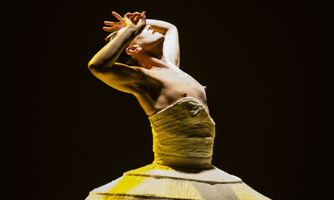
“In this work, I am interested in the dynamics of how Stravinsky transformed the classical world of music by evoking emotions through patterns, rather than through expression, and these patterns were rooted in the concept of a woman dancing herself to death. This approach is a huge inspiration to me. But in a sense I hope to reinvestigate it, not just through patterns, as Stravinsky did, but also through exploring the human condition. A rupture in the mind, a death in the body, and a birth in the soul, all remind us that the mind and imagination are wild and self-generating. In addition, to be creating this work with three different composers, Nitin Sawhney, Jocelyn Pook and Ben Frost, allows us to discover many different sound-worlds, using Stravinsky as the key, the guide, the map.”
- Akram Khan
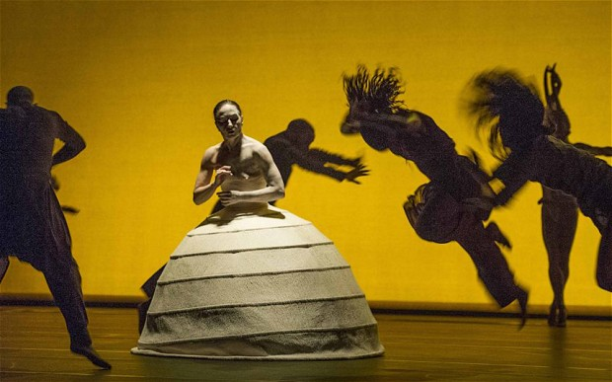
Shockingly imagined chaos … Akram Khan's iTMOi, based on Stravinsky's Rite of Spring, at Sadler's Wells. Photograph: Rex Features
The genius of Stravinsky's 1913 ballet, The Rite of Spring, looked two ways: embodying the atavistic impulses of human nature and the shattering birth pangs of modern art.
Exactly 100 years after its premiere, the choreographer and dancer Akram Khan sets out to explore the nature of that genius. Yet while iTMOi (which stands for In the Mind of Igor) is inspired by the life and work of the Russian composer, what we see on stage often seems to have issued straight from the mind of Khan. It's his own angels and demons in play, his own experience of the hurtling, dangerous forces that generate art.
Stravinsky's religious faith and the dark allure of sacrifice are transposed by Khan to the figure of a trance preacher, whose rasping, gabbling exhortations relay the story of Abraham, called on by God to kill his son. He seems a servant of hell rather than heaven, and he's joined by equally threatening figures: a remote queen in a fantastical headdress; a young girl, half-innocent, half-sexualised, and a horned beast who lopes with a liquid, insinuating grace around the stage.
For one long section, the queen presides over a set of neatly ordered folkloric dances: yet a thudding, convulsive violence repeatedly breaks through the dancers' bodies. The music (composed by Nitin Sawhney, Ben Frost and Jocelyn Pook) orchestrates equally brutal juxtapositions, with sweet melodies overwhelmed by dread-inducing cacophonies of sound. When the girl finally embarks on her ritual dance that will culminate in death, the artist-creature who's born from her efforts is a cringing Caliban figure, tormented and flayed.
As metaphors, these images rarely cohere, yet they jolt and assault us as viscerally as The Rite of Spring did its original audience. And while iTMOi is a far from perfect work, fractured and oddly paced, it is through Khan's shockingly imagined chaos that we're drawn into the creative maelstrom from which art is born.

